
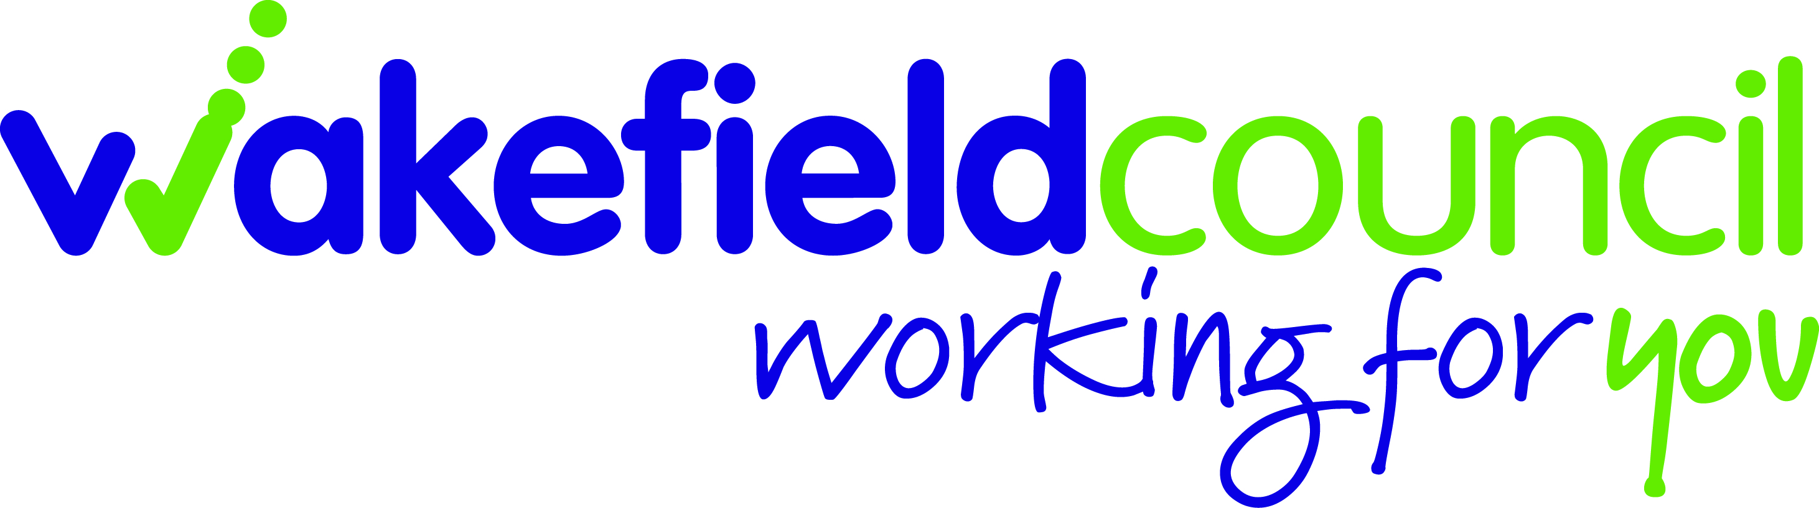

UKYP ELECTIONS 2024 - BALLOT PAPER

This is your ballot paper for the 2024 UKYP Election. It can only be used by you. It is your responsibility to keep the way you use your vote a secret.

This ballot paper is for the election of a Member of the UKYP and Deputy Member of the UKYP to represent the Wakefield Council district.

To vote, mark an “X” against the candidate you wish to vote for, fold the letter in half and give to the Youth Worker / Lead Worker who gave you it.

WAKEFIELD METROPOLITAN DISTRICT COUNCIL
Printed & Published by the UKYP RETURNING OFFICER, JOANNE BROWNING, YOUTH WORK TEAM , CROFTON YOUNG PEOPLE’S CENTRE, HIGH STREET, CROFTON, WAKEFIELD, WF4 1NF

------------------------------------------------------------------------------------------------------------------------------------

Election of a Member of the U.K. Youth Parliament 2024
For the Wakefield Council District

VOTE FOR ONLY ONE CANDIDATE

Candidate | Mark ‘X’ in the column below for which candidate you want
A
B
C
D
E

