Are you creative? Do you enjoy culture and creativity? Would you like to help other people to take part in and benefit from creativity? If the answers to those questions are yes…become a SPARK Arts Ambassador!
What is SPARK?
SPARK is a partnership of arts and cultural* organisations in the Wakefield District who have come together to inspire young people in Wakefield to take part, enjoy and benefit from rich arts and cultural experiences across the district. They are a champion for arts, culture and creativity. They remove barriers and raise awareness to make these opportunities accessible within and outside of formal education.
It includes the Yorkshire Sculpture Park, The Music Service, Libraries, Wakefield Museums and Castles, Theatre Royal Wakefield, Long Division, Wakefield College and Yew Tree Youth Theatre.

Who are SPARK Arts Ambassadors?
Arts Ambassadors are young people from across the Wakefield District aged 16 – 25 years old, who are interested in arts and culture and want to shape the cultural and arts offer as part of a new youth panel. This panel needs to be diverse and represent the whole of the Wakefield District.
What will you do?
With support from SPARK to develop skills and knowledge you will:
- champion the arts with peers and spread the word about opportunities in arts and culture
- help SPARK to connect with young people in the Wakefield District
- feel confident to share their opinions and understanding with others
- connect with likeminded young people from across the district
- find out what young people want from arts and culture in the Wakefield District
- co-produce relevant and inspirational events and programmes with arts and culture organisations to create opportunities for as many people as possible to benefit from the transformative impact of creative experiences
- help break down barriers between young people and arts and culture
- develop skills and understanding to help achieve your aspirations
- shape the way the panel is run in future
What will that look like?
Online and in person training over July and August (amount to be confirmed)
Online and in person panel meetings once a month from September onwards (venue to be confirmed)
Occasional additional meetings and events when needed – not all the panel will be needed
How to find out more
Link up with us on social media – Instagram, Facebook and Twitter
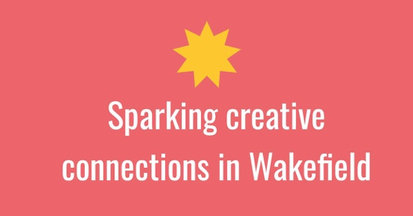
Message us on any of them or email sarah@yew-tree.com for more information about becoming an arts and culture champion.

“It’s an opportunity to transform you into the person you’re aiming to become with your limitless creativity.” Wakefield College Student

